SAFE SPORT REPORTING

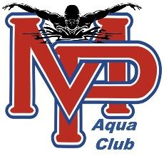

- USA Swimming (719) 866-4578 Deal with a Safe Sport Concern.

- U.S. Center for SafeSport to make a report. Use the online reporting form, call 833-5US-SAFE (587-7233), or find more information at www.uscenterforsafesport.org.

Text anonymous tips to 888-270-SWIM (7946)

MPAC SAFE SPORT COORDINATOR-
Valorie Gardner gardnerlynnvalorie@yahoo.com

